Creating the Collection Class (Properties)

Adding the Presentation Layer 1

Adding the Presentation Layer
As part of the admin system web site you should have a web form called something like AddressBookList.aspx…
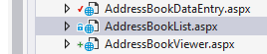
Open the form in design view so that you are in a position to add some controls.
In design view add a list box to the web form…
and name it lstAddressList (lst short for list) like so…
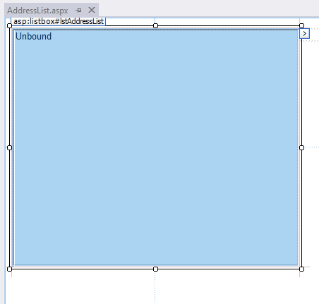

We need to add the following code to the form created above.
Right click on the web form and select view code…
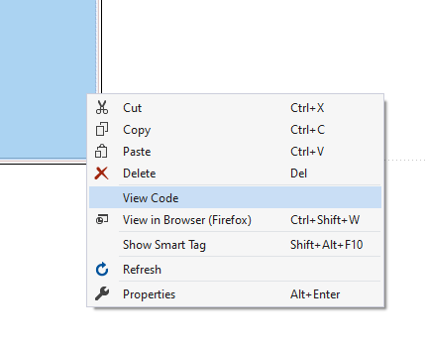
Modify the code for the page from this…
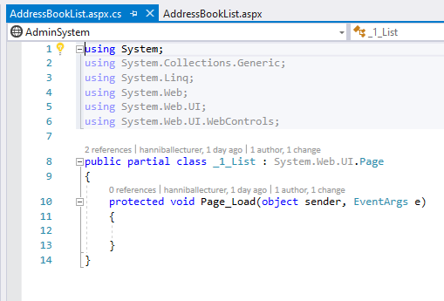
To this…
Add a Using at the top of the class…
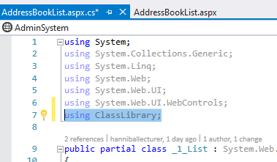
The modify the existing code like so…
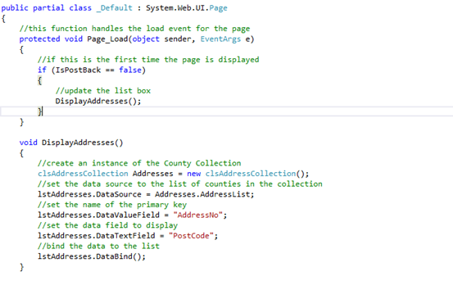
This code should update the list box with a list of post codes.
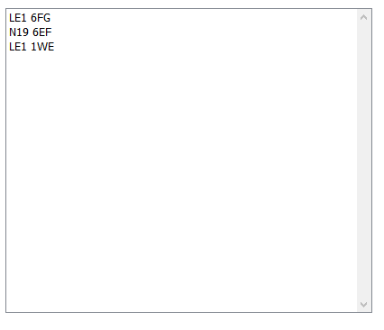
Finally finish off your Git Hub day.

